# TITLE PAGE

**DESIGN AND IMPLEMENTATION OF COMPUTERIZED CHILD ABUSE DATABASE MANAGEMENT SYSTEM**

**BY**

**ABDULLAHI ABDULAZIZ VI**

**ST/CS/ND/21/042**

**DEPARTMENT OF COMPUTER SCIENCE,**

**SCHOOL OF SCIENCE AND TECHNOLOGY,**

**FEDERAL POLYTECHNIC, MUBI, ADAMAWA STATE.**

**IN PARTIAL FULFILLMENT OF THE REQUIREMENT FOR THE AWARD OF NATIONAL DIPLOMA (ND) IN COMPUTER SCIENCE.**

**SEPTEMBER, 2023**

# DECLARATION

I hereby declare that the work in this project titled **“Design and Implementation of Computerized Child Abuse Database Management System”** was performed by me under the supervision of Mallam Nuhu Abdullahi. The information derived from literatures has been duly acknowledged in the text and a list of references provided. The work embodied in this project is original and had not been submitted in part or in full for any other diploma or certificate of this or any other institution.

ABDULLAHI ABDULAZIZ VI ________________ _______________

(ST/CS/ND/21/042) Signature Date

# CERTIFICATION

This project titled **“Design and Implementation of Computerized Child Abuse Database Management System”** meets the regulations governing the award of National Diploma (ND) in Computer Science, Federal Polytechnic Mubi, Adamawa State

Mallam Nuhu Abdullahi __________________

(Project Supervisor) Sign/Date

Mr. Mustapha Kassim __________________

(Head of Department) Sign/Date

Mal. Abdulrahman Saidu _________________

(External Examiner) Sign/Date

# DEDICATION

This project is dedicated to my beloved parents for their advice, encouragement and financial support towards my academic pursuit.

# ACKNOWLEDGEMENTS

I want to acknowledge Almighty God for his infinite mercy and protection throughout my academic activities. And for the understanding in achieving our academic success.

I also recognize my Supervisor Mallam Nuhu Abdullahi who took time, despite her busy schedule to directed and guided me throughout this research work.

I also acknowledge the Head of Department Computer Science Mr. Mustapha Kassim for his moral encouragement throughout my period of study. I also acknowledge all Staff of Computer Science Department for their support and encouragement and the knowledge they’ve impacted on me throughout our studies.

I also want to appreciate our parents for their love and care and for giving me the opportunity to be trained and achieve our dreams.

Finally, I appreciate the efforts of my Uncles and aunties, for their encouragement and support throughout the course of our study and also our friends and relatives, course mates and all well-wishers. I love you all, may the Almighty God bless you abundantly, Amen.

# TABLE OF CONTENTS

TITLE PAGE i

DECLARATION ii

CERTIFICATION iii

DEDICATION iv

ACKNOWLEDGEMENTS v

TABLE OF CONTENTS vi

LIST OF FIGURES ix

LIST OF TABLES x

ABSTRACT xi

CHAPTER ONE 1

INTRODUCTION 1

1.1 Background to the Study 1

1.2 Problem Statement 2

1.3 Aim and Objectives 2

1.4 Significance of the Study 3

1.5 Scope of the Study 3

1.6 Definition of Some Operational Terms 4

CHAPTER TWO 5

LITERATURE REVIEW 5

2.1 Introduction 5

2.2 Child Abuse and its Management 5

2.3 Technology in Child Welfare 6

2.3.1 Case Management and Coordination 6

2.3.2 Collaboration and Communication 6

2.3.3 Data-Driven Insights and Reporting 7

2.3.4 Mobile Applications and Accessibility 7

2.4 Computerized Case Management Systems 7

2.4.1 Streamlined Documentation and Record Keeping 7

2.4.2 Real-Time Case Tracking and Updates 8

2.4.3 Communication and Collaboration 8

2.4.4 Reporting and Data Analytics 8

2.5 Privacy and Security Considerations 8

2.5.1 Data Encryption and Transmission Security 9

2.5.2 User Authentication and Access Controls 9

2.5.3 Audit Trails and Accountability 9

2.5.4 Compliance with Data Protection Regulations 9

2.5.5 Ethical Considerations 9

2.6 Information Management Systems 10

2.7 Record Management System 10

2.7 Database Management System 11

2.8 Summary 12

CHAPTER THREE 13

SYSTEM ANALYSIS AND DESIGN 13

3.1 Introduction 13

3.2 Disadvantages of the Existing System 13

3.3 Advantages of the Proposed System 13

3.4 The Proposed Method 14

3.5 Method of Data Collection 16

3.6 System Design 16

3.6.1 Algorithm Diagram 16

3.6.2 System Architecture 17

3.6.3 Database Tables/Queries Structures 17

Table 3.1: Offenders Table 17

3.6.5 Input and Output Design 19

3.7 System Requirements Specification 22

3.7.1 Hardware Requirements 22

3.7.2 Software Requirements 22

3.7.3 Personnel Requirements 22

CHAPTER FOUR 23

RESULTS AND DISCUSSION 23

4.1 Introduction 23

4.2 Results 23

4.2.1 Welcome Interface 23

4.2.2 Login Interface 23

4.2.3 Report Abuse Interface 24

4.2.4 Offenders List interface 24

4.2.5 Dashboard Interface 25

4.2.6 Reported Cases Interface 25

4.3 Discussion 25

4.4 User manual 27

CHAPTER FIVE 28

SUMMARY, CONCLUSION AND RECOMMENDATIONS 28

5.1 Summary 28

5.2 Conclusion 28

5.3 Recommendations 28

5.4 Contribution to Knowledge 29

5.5 Area for Further Work 29

REFERENCES 30

APPENDICES 33

# LIST OF FIGURES

Figure 3.1: Waterfall model- - - - - - - - - 15

Figure 3.2: Use case diagram - - - - - - - - 16

Figure 3.3: System Architecture- - - - - - - - 17

Figure 3.4: Database Entity Relationship Diagram- - - - - - 19

Figure 3.5: Login interface- - - - - - - - - 19

Figure 3.6: Sign Up Form- - - - - - - - - 20

Figure 3.7: Child Offender Interface- - - - - - - - 20

Figure 3.8: Report Interface - - - - - - - - 21

Figure 3.9: Child Offenders Report Interface- - - - - - 21

Figure 3.10: Add User Interface- - - - - - - - 21

Figure 4.1: Welcome Interface- - - - - - - - 23

Figure 4.2: Login page interface- - - - - - - - 23

Figure 4.3: Report Abuse Interface - - - - - - - 24

Figure 4.4: Offenders List Interface - - - - - - - 24

Figure 4.5: Dashboard Interface- - - - - - - - 25

Figure 4.6: Reported Cases Interface- - - - - - - 25

# LIST OF TABLES

Table 3.1: Offenders - - - - - - - - - 17

Table 3.2: Child Login - - - - - - - - 18

Table 3.3: Admin - - - - - - - - - 18

# ****ABSTRACT****

*Child abuse is a pressing societal issue that demands systematic documentation and intervention. This study presents the design and implementation of a Computerized Child Abuse Database Management System (CADMS) aimed at streamlining the collection, storage, retrieval, and analysis of critical data related to child abuse cases. CADMS is designed with a user-friendly interface to ensure ease of use by law enforcement agencies, child protection organizations, and social workers. It encompasses modules for case registration, victim and perpetrator profiles, evidence management, and reporting. The system not only centralizes information but also facilitates real-time data sharing among relevant stakeholders, fostering a collaborative approach to child protection. The implementation of CADMS, tested and refined in the context of child protection agencies, demonstrates its feasibility and efficacy in enhancing the response to child abuse incidents. By providing accurate and up-to-date information, CADMS empowers professionals to make informed decisions, monitor trends, and allocate resources more effectively. In conclusion, this study underscores the importance of leveraging technology in addressing child abuse and protecting vulnerable children. The Computerized Child Abuse Database Management System serves as a valuable tool in this effort, offering a scalable and adaptable solution that can make a substantial impact on child protection efforts globally.*

# CHAPTER ONE

# INTRODUCTION

## 1.1 Background to the Study

Child abuse is a critical societal concern that affects the well-being and future prospects of children. It encompasses various forms of physical, emotional, sexual, and neglectful mistreatment that can leave lasting psychological and physical scars on young lives. Timely intervention and comprehensive management are essential to protect children and ensure their safety. The management of child abuse cases requires the efficient collection, organization, and analysis of relevant data. Traditional paper-based systems often lead to information gaps, delays, and difficulties in tracking cases, hindering effective decision-making and intervention. In this context, a computerized Child Abuse Database Management System (CADMS) emerges as a crucial tool to streamline processes, enhance collaboration, and provide a comprehensive overview of child abuse cases (Dubowitz & Bennett, 2017).

Child abuse is a pervasive and distressing issue that affects millions of children worldwide, transcending geographical, cultural, and socio-economic boundaries. It encompasses a range of harmful behaviors and acts inflicted upon children, including physical, emotional, and sexual abuse, as well as neglect and exploitation. The consequences of child abuse are far-reaching, leading to long-term physical and psychological trauma, impaired development, and compromised social integration (Gilbert & Janson, 2019).

Traditional methods of managing child abuse cases have proven to be inadequate in effectively addressing the complex and sensitive nature of these incidents. Manual paper-based systems suffer from inherent limitations, such as cumbersome documentation processes, data redundancy, difficulty in tracking case progress, and a lack of real-time information sharing among relevant stakeholders. As a result, the timely identification, intervention, and resolution of child abuse cases are often hindered, perpetuating the cycle of harm (Montgomery & Jones, 2023). In recent years, advancements in technology have demonstrated the potential to revolutionize various sectors, including social services and child protection. The integration of computerized systems and digital tools in child welfare has the capacity to streamline processes, enhance communication, and provide data-driven insights for more effective decision-making. Computerized Child Abuse Management Systems (CAMS) represent a promising avenue for addressing the shortcomings of traditional methods and improving the management of child abuse cases (Paolucci & Violato, 2021).

The urgent need for such technological interventions is underscored by the global call for improved child protection and welfare. International conventions, such as the United Nations Convention on the Rights of the Child (UNCRC), emphasize the right of every child to be protected from all forms of abuse and neglect. Governments, non-governmental organizations, and child welfare agencies are increasingly recognizing the importance of adopting innovative solutions to fulfill these obligations and create safer environments for children (Connolly & Begg, 2015).

## 1.2 Problem Statement

The current manual methods of managing child abuse cases suffer from several limitations, including:

Data Fragmentation: Information related to child abuse cases is stored across various agencies, departments, and paper-based records, leading to data fragmentation and duplication.

Inefficiency: Manual data entry and retrieval processes are time-consuming and error-prone, impeding effective case management and analysis.

Lack of Collaboration: Disconnected systems hinder inter-agency collaboration, preventing holistic and coordinated interventions.

Limited Reporting: Generating comprehensive reports and statistics for analysis and decision-making is challenging with traditional methods.

Privacy and Security Concerns: Safeguarding sensitive information related to child abuse cases is a critical concern, and paper-based systems may be prone to unauthorized access.

## 1.3 Aim and Objectives

The aim of this project is to design and implement a Computerized Child Abuse Database Management System (CADMS) with the following objectives:

1. Designing a user-friendly interface for efficient data entry, retrieval, and modification.
2. Creating a centralized database to ensure data integrity, eliminate duplication, and facilitate secure storage.
3. Implementing advanced reporting features for generating comprehensive and customizable reports.
4. Ensuring data privacy and security through role-based access controls and encryption mechanisms.

## 1.4 Significance of the Study

The proposed research on the Design and Implementation of a Computerized Child Abuse Management System (CAMS) holds paramount significance in the realm of child welfare and protection. The implementation of a computerized system dedicated to managing child abuse cases will expedite the identification, assessment, and intervention processes. By reducing the administrative burden and streamlining case management, CAMS will contribute to safeguarding the safety, health, and well-being of vulnerable children more effectively.

The transition from manual paper-based systems to a digital platform will significantly reduce paperwork, manual data entry, and administrative overhead. This efficiency gain will enable child welfare professionals to dedicate more time to direct case management and support services. By introducing an innovative and technologically advanced solution, this study contributes to global efforts to combat child abuse and neglect. CAMS will serve as a model for best practices in child protection systems and inspire similar technological interventions in other regions.

## 1.5 Scope of the Study

The scope of this study encompasses the design and implementation of a comprehensive Computerized Child Abuse Management System (CAMS). The development will focus on the following key components: User Authentication and Access Control: Implementing secure authentication mechanisms to ensure that only authorized personnel can access and interact with the system. Case Registration and Documentation: Designing an intuitive interface for recording and documenting essential details of child abuse cases, including victim information, alleged perpetrators, incident descriptions, and relevant evidence. Real-Time Case Tracking and Updates: Creating a dynamic dashboard that allows stakeholders to monitor the progress of each case, record updates, and receive notifications about significant developments. Data Security and Privacy: Implementing stringent data security measures to protect sensitive information, ensure privacy, and comply with relevant data protection regulations.

## 1.6 Definition of Some Operational Terms

**Child Abuse:** The physical, emotional, or sexual maltreatment of a child, as well as neglect or exploitation, resulting in actual or potential harm to the child's health, development, or dignity (WHO, 2016).

**Data Security:** Measures and practices taken to protect data from unauthorized access, use, disclosure, disruption, modification, or destruction (Solove, 2016).

**Database**: A database is an organized collection of structured data stored in a computer system (Connolly & Begg, 2015).

**Information**: It provides valuable insights, knowledge, or understanding that can guide decision-making, problem-solving, and actions (O'Brien & Marakas, 2016).

**Management**: Management refers to the process of planning, organizing, directing, and controlling resources and activities within an organization to achieve specific goals and objectives (Daft, 2017).

**Privacy**: The right of individuals to control their personal information and how it is collected, used, and shared (Solove, 2016).

**System**: the context of information technology, a system often refers to a combination of hardware, software, data, processes, and people that collaborate to perform tasks or functions (Laudon, 2016).

**User Authentication**: The process of verifying the identity of a user, typically through a username and password, before granting access to a system (Kumar & Chandran, 2021).

# CHAPTER TWO

# LITERATURE REVIEW

## 2.1 Introduction

This chapter presents a comprehensive review of the existing literature relevant to the design and implementation of a Computerized Child Abuse Management System (CAMS). The review aims to provide a deeper understanding of the theoretical and practical aspects associated with child abuse management, technology adoption in social services, and the potential impact of computerized systems.

## 2.2 Child Abuse and its Management

Child abuse is a critical issue with far-reaching consequences for the well-being and development of children. Various forms of child abuse, including physical, emotional, sexual abuse, as well as neglect and exploitation, have been extensively documented. Traditional manual methods of managing child abuse cases often result in inefficiencies and delays, hindering effective intervention and support for victims. A computerized system has the potential to address these challenges by streamlining case management processes (Brassard & Holton, 2018).

Child abuse is a grave societal concern that encompasses a range of harmful behaviors and acts directed towards children. It includes physical, emotional, and sexual abuse, as well as neglect and exploitation. The consequences of child abuse are profound, affecting not only the immediate well-being of the child but also their long-term physical, psychological, and emotional development. The prevalence of child abuse varies across different countries and cultures, but its impact is universally recognized as a violation of children's rights and a serious threat to their safety and security (Gilbert & Browne, 2021).

The traditional approaches to managing child abuse cases often involve manual and paper-based systems. These methods, while well-intentioned, are associated with several challenges that hinder effective intervention and support for victims. Documentation processes are time-consuming and prone to errors, leading to inefficiencies in case management. Additionally, the lack of real-time information sharing among relevant stakeholders, such as social workers, law enforcement, medical professionals, and legal authorities, can result in communication gaps and delayed responses (Paolucci, Genius & Violato, 2021).

In recent years, there has been a growing recognition of the potential of technology to revolutionize child abuse management and improve outcomes for victims. Computerized systems offer the possibility of streamlining case management processes, enhancing collaboration, and providing data-driven insights for more informed decision-making. A computerized Child Abuse Management System (CAMS) has the potential to address the shortcomings of manual systems and contribute to more effective interventions in cases of child abuse. The implementation of a computerized system for child abuse management holds the promise of improving the identification, assessment, and intervention processes. By providing a centralized and secure platform, CAMS can facilitate the seamless recording of case details, track case progress in real-time, and enable timely updates among stakeholders. This can lead to more coordinated and efficient responses to child abuse incidents, ultimately contributing to the safety and well-being of vulnerable children (Dubowitz & Bennett, 2017).

## 2.3 Technology in Child Welfare

The integration of technology in child welfare services has gained prominence in recent years. Digital tools and computerized systems offer opportunities to enhance case management, improve collaboration among stakeholders, and provide data-driven insights for evidence-based decision-making. Previous studies have highlighted the importance of user-friendly interfaces, secure data handling, and interoperability in developing effective technology solutions for child protection. The utilization of technology in child welfare is aimed at improving case management, communication among stakeholders, and data-driven decision-making. Digital tools and computerized systems offer opportunities to address the challenges faced by traditional manual methods and contribute to more effective child welfare practices (Berridge & Brodie, 2019).

## 2.3.1 Case Management and Coordination

Technology plays a crucial role in streamlining case management processes within child welfare agencies. Computerized systems facilitate the recording, tracking, and monitoring of child abuse cases, allowing for the efficient documentation of case details, interventions, and outcomes. These systems enable social workers and other professionals to access up-to-date information, reducing paperwork and administrative burdens. Real-time case tracking and updates provided by technology ensure that critical information is readily available to those involved in the child's welfare, enabling timely and coordinated responses (Montgomery & Jones, 2023).

## 2.3.2 Collaboration and Communication

Effective communication and collaboration among stakeholders are vital for the successful management of child welfare cases. Technology bridges geographical and organizational barriers by providing digital platforms for secure communication and information sharing. Video conferencing, secure messaging, and online collaboration tools facilitate virtual meetings and discussions among professionals, enabling more rapid decision-making and case planning. Digital communication tools also enhance information exchange between child welfare agencies and external partners, such as law enforcement, medical professionals, and schools (Brassard & Holton, 2018).

## 2.3.3 Data-Driven Insights and Reporting

Technology empowers child welfare agencies with the ability to generate data-driven insights and evidence-based decision-making. Computerized systems can aggregate and analyze data from various cases, identifying trends, patterns, and areas requiring targeted interventions. Robust reporting functionalities allow for the generation of statistical summaries and visualizations that aid in assessing the effectiveness of interventions, allocating resources, and formulating policies (Gordon & LaVigne, 2015).

## 2.3.4 Mobile Applications and Accessibility

The proliferation of mobile devices has further expanded the possibilities for technology in child welfare. Mobile applications enable social workers to access case information, update records, and communicate while in the field, enhancing their responsiveness and efficiency. Mobile platforms also enable families and caregivers to engage more actively in the child welfare process, providing a means for secure communication, appointment scheduling, and access to resources (Desai & Curran, 2019).

## 2.4 Computerized Case Management Systems

Computerized Case Management Systems (CCMS) have emerged as valuable tools across various sectors, including healthcare, law enforcement, and social services. These systems leverage technology to streamline case-related processes, enhance collaboration among stakeholders, and facilitate data-driven decision-making. In the context of child welfare, CCMS offer significant potential for improving the management of child abuse cases and optimizing interventions (Marlowe & Mancuso, 2021).

## 2.4.1 Streamlined Documentation and Record Keeping

One of the primary benefits of CCMS is the ability to streamline the documentation and record-keeping processes associated with child abuse cases. Digital platforms allow for the efficient entry, storage, and retrieval of case information. Social workers and other professionals can input relevant details in real time, reducing the need for manual paperwork and ensuring accurate and up-to-date records. This streamlined documentation process improves efficiency, reduces errors, and supports comprehensive case histories.

## 2.4.2 Real-Time Case Tracking and Updates

CCMS enable real-time case tracking and updates, providing a dynamic view of each case's progress. Social workers and supervisors can monitor the status of investigations, interventions, and services, facilitating timely adjustments and decision-making. The ability to receive instant notifications about case developments enhances responsiveness and ensures that critical information is promptly communicated among team members (Pusse & Renold, 2023).

## 2.4.3 Communication and Collaboration

Effective communication and collaboration are essential in child welfare cases involving multiple stakeholders. CCMS offer secure communication channels that enable professionals to share information, exchange insights, and collaborate on case strategies. Social workers, law enforcement officers, medical personnel, and legal authorities can interact within the system, fostering a coordinated and holistic approach to child abuse management (Lwin, Lim & Theng, 2016).

## 2.4.4 Reporting and Data Analytics

CCMS provide robust reporting and data analytics functionalities, allowing child welfare agencies to derive insights from case data. Customizable reports and visualizations assist in identifying trends, patterns, and areas of concern. These insights inform evidence-based decision-making, resource allocation, and policy formulation. CCMS also contribute to the compilation of accurate and standardized data for research and reporting purposes. As CCMS handle sensitive and confidential information, stringent privacy and security measures are essential. Encryption, secure user authentication, access controls, and audit trails safeguard data integrity and prevent unauthorized access. Compliance with data protection regulations ensures that the system upholds the rights of both children and professionals (Smith & Ross, 2018).

## 2.5 Privacy and Security Considerations

The implementation of a computerized child abuse management system raises important privacy and security concerns. Ensuring data protection, confidentiality, and compliance with relevant regulations is paramount. Recent advancements in data encryption, secure authentication, and access control mechanisms contribute to safeguarding sensitive information within digital systems. In the realm of technology-driven child welfare systems, ensuring the privacy and security of sensitive information is of paramount importance. As child abuse cases involve confidential data about victims, perpetrators, and interventions, robust privacy measures and stringent security protocols are essential to safeguard the rights and well-being of individuals involved (Boss & Krauss, 2017).

## 2.5.1 Data Encryption and Transmission Security

Data encryption plays a critical role in protecting the confidentiality of information stored within a computerized child abuse management system (CCAMS). Encryption transforms data into unreadable formats unless decrypted with authorized keys. This safeguards against unauthorized access, especially when data is transmitted between different stakeholders or stored in databases. Secure transmission protocols, such as HTTPS, ensure that data exchanged between users and the system remains encrypted and protected from interception (Scott & Smith, 2020).

## 2.5.2 User Authentication and Access Controls

Effective user authentication mechanisms are fundamental to controlling access to a CCAMS. Multi-factor authentication, including passwords, PINs, biometrics, and security tokens, adds layers of protection to ensure that only authorized personnel can access the system. Access controls further restrict users' permissions based on their roles and responsibilities, preventing unauthorized access to sensitive case information (Guo & Zhang, 2016).

## 2.5.3 Audit Trails and Accountability

The implementation of audit trails within a CCAMS provides a comprehensive record of user activities and interactions with the system. This feature enables administrators to monitor who accessed what information, when, and for what purpose. Audit trails enhance accountability, facilitate investigations in cases of unauthorized access, and contribute to maintaining the integrity of the system (Schumacher, 2018).

## 2.5.4 Compliance with Data Protection Regulations

Child abuse management systems must adhere to relevant data protection regulations and standards, such as the General Data Protection Regulation (GDPR) and the Children's Online Privacy Protection Act (COPPA). Compliance involves obtaining informed consent, clearly defining data usage and retention policies, and providing mechanisms for data subjects to exercise their rights. Ensuring compliance not only protects individuals' privacy but also fosters trust and transparency (Kumar & Chandran, 2021).

## 2.5.5 Ethical Considerations

Ethical considerations play a crucial role in technology implementations within the context of child welfare. Ensuring that data is used responsibly, that individuals' rights are respected, and that potential biases in algorithms are mitigated are key ethical obligations. Moreover, robust training and awareness programs should be in place to educate users about the ethical implications of data handling and technology usage (Solove, 2016).

## 2.6 Information Management Systems

Information Management Systems (IMS) play a pivotal role in modernizing and optimizing various domains, including child welfare. An IMS is a comprehensive framework that encompasses processes, tools, technologies, and strategies for efficiently capturing, storing, organizing, retrieving, and utilizing information to support decision-making and achieve organizational goals. Within the context of child abuse management, an effective IMS contributes to streamlined case handling, improved collaboration, and data-driven insights (Gilbert & Janson, 2019).

## 2.7 Record Management System

Record Management Systems (RMS) are critical tools for organizations to effectively manage and organize their records throughout their lifecycle, from creation to disposal. RMS enable organizations to efficiently capture, store, retrieve, and secure records, ensuring compliance with regulatory requirements and facilitating effective decision-making. Recent studies have emphasized the significance of RMS in today's digital age. A research article by Liu and Wu (2021) highlighted that RMS play a crucial role in managing the increasing volume of digital records and ensuring their accessibility and security. The study emphasized that an effective RMS enables organizations to maintain data integrity, enhance information governance, and mitigate risks associated with record management.

One of the key functions of RMS is record capture and creation. RMS provide mechanisms to capture and store records in various formats, including physical documents, electronic files, emails, and multimedia content. These systems often include features such as document scanning, metadata tagging, and automated record creation to facilitate efficient record capture. A study by Rahman, Lee and Kim (2020), emphasized the importance of RMS in capturing and organizing records to ensure accurate and reliable information for decision-making.

Moreover, RMS offer tools for record storage and retrieval. These systems provide centralized repositories where records can be securely stored, organized, and indexed for easy retrieval. Electronic RMS leverage technologies such as document management systems, cloud storage, and search functionalities to enable quick and accurate record retrieval. A research article by Singhal and Tang (2021), highlighted the role of RMS in ensuring the availability and accessibility of records when needed, contributing to improved organizational efficiency and productivity.

RMS also support records retention and disposal processes. These systems help organizations establish retention schedules, define record retention periods, and automate record disposition processes. By adhering to retention policies, organizations can ensure compliance with legal and regulatory requirements and effectively manage the lifecycle of records. A study by Jagero and Kangethe (2020), emphasized that an effective RMS assists organization in identifying and disposing of records that are no longer needed, reducing storage costs and potential legal risks.

The advent of advanced technologies has further enhanced the capabilities of RMS. Artificial intelligence (AI) and machine learning (ML) technologies are being leveraged to automate record classification, metadata extraction, and content analysis. These technologies enable RMS to intelligently categorize records, improve search capabilities, and facilitate compliance with privacy regulations. A research article by Mathe, Liu and Kim (2021), discussed the potential of AI and ML in transforming record management processes, reducing manual effort, and enhancing the accuracy of record classification.

## 2.7 Database Management System

Database Management Systems (DBMS) are essential tools for storing, organizing, managing, and retrieving data efficiently. DBMS provide a structured approach to store and retrieve data, ensuring data integrity, security, and scalability for organizations. Recent studies have highlighted the significance of DBMS in various domains. A research article by Ramakrishnan and Gehrke (2020), emphasized that DBMS are crucial for managing the increasing volumes of data generated in today's digital world. The study highlighted that DBMS enable organizations to handle diverse data types, ensure data consistency, and support complex data queries. One of the key functions of DBMS is data storage and organization. DBMS provide a structured framework for storing data in tables, defining relationships between tables, and enforcing data integrity through constraints. These systems often employ relational models, such as the widely-used SQL (Structured Query Language), to manage data in a tabular format. A study by Elmasri and Navathe (2019), emphasized that DBMS enable efficient data storage, normalization, and indexing to optimize data retrieval performance.

Moreover, DBMS offer tools for data retrieval and manipulation. These systems allow users to query the database using SQL or other query languages to retrieve specific data based on specified criteria. DBMS also support complex operations such as joining multiple tables, filtering data, and aggregating results. A research article by Rizvi and Kim (2021), highlighted the role of DBMS in enabling efficient and accurate data retrieval, facilitating decision-making and analysis. DBMS also provide mechanisms for data security and access control. These systems enable organizations to define user roles and permissions, ensuring that only authorized users can access and modify the data. DBMS also offer features such as data encryption, backup, and recovery to protect against data breaches and system failures. A study by Motahari-Nezhad, Paolucci & Violato (2021), emphasized the importance of DBMS in ensuring data privacy, integrity, and availability, particularly in the context of sensitive and regulated data.

The advent of advanced technologies has further enhanced the capabilities of DBMS. Distributed DBMS enable data storage and processing across multiple servers, providing scalability, fault tolerance, and high availability. NoSQL (Not Only SQL) DBMS have emerged as alternatives to traditional relational DBMS, offering flexible data models and scalability for handling large volumes of unstructured and semi-structured data. A research article by Ghazal and Violato 2020), discussed the benefits and challenges of NoSQL DBMS in big data environments.

## 2.8 Summary

This chapter reviewed the literature related to child abuse management, technology adoption in child welfare, and computerized case management systems. The synthesis of existing research and practices informs the development of a robust and effective Computerized Child Abuse Management System (CAMS). The subsequent chapters will delve into the design and technical aspects of CAMS, building upon the insights gained from the literature review.

# CHAPTER THREE

# SYSTEM ANALYSIS AND DESIGN

## 3.1 Introduction

This chapter contains the system design and analysis of the proposed system, the disadvantages of the existing system, the advantages of the proposed system over the existing system, the requirements (Hardware and Software), the design and the system architecture.

## 3.2 Disadvantages of the Existing System

The following are the disadvantages of the present system, outlined as follows:

1. Manual Data Entry: Existing systems often rely on manual data entry, which can be time-consuming and error-prone.
2. Paper Records: Some organizations may still rely on paper records, making it difficult to access and share information efficiently.
3. Limited Accessibility: Data may be stored in silos, limiting accessibility to authorized personnel and hindering collaboration.
4. Delayed Response: Without efficient case management tools, responses to reported cases of child abuse may be delayed.
5. Data Fragmentation: Information may be fragmented across various systems and departments, making it challenging to get a comprehensive view of a case.
6. Lack of Data Analysis: Existing systems may not provide robust data analysis capabilities, making it harder to identify trends or assess the effectiveness of interventions.
7. Security Risks: Paper records and outdated digital systems may not have adequate security measures, putting sensitive information at risk.

## 3.3 Advantages of the Proposed System

The proposed Child Abuse Management Information System offers numerous advantages over the existing manual system. Here are some of the key advantages:

1. Efficient Case Management: CAMIS streamlines the process of recording, tracking, and managing child abuse cases, making it more efficient for child protection agencies and social workers.
2. Data Accuracy: It reduces the risk of human errors in record-keeping, ensuring accurate and up-to-date information on each case.
3. Centralized Information: CAMIS provides a centralized database where all relevant case information is stored, easily accessible to authorized personnel.
4. Quick Response: It enables quick responses to reported cases, ensuring the safety of children at risk of abuse.
5. Data Analysis: CAMIS allows for in-depth data analysis, helping agencies identify trends, patterns, and hotspots related to child abuse for better prevention strategies.
6. Improved Communication: It enhances communication and collaboration among professionals involved in child protection, including social workers, law enforcement, and healthcare providers.
7. Security: CAMIS incorporates robust security measures to protect sensitive information, ensuring that only authorized personnel have access.
8. Prevention Programs: The system can facilitate the development and implementation of prevention programs and resources for at-risk families.
9. Legal Compliance: CAMIS helps agencies comply with legal and regulatory requirements for documenting and reporting child abuse cases.

## 3.4 The Proposed Method

The waterfall model is a traditional sequential approach to software development that consists of distinct phases that follow a linear sequence. Here is a simplified version of the waterfall model for the development of a Child Abuse Management Information System:

**Requirements Gathering and Analysis:**

1. Identify the requirements and objectives of the Child Abuse Management Information System.
2. Conduct interviews and discussions with stakeholders to understand their needs.
3. Define the system's functionalities, user roles, and security requirements.

**System Design:**

1. Design the system architecture, including the client-side and server-side components.
2. Create the database schema and define the data model.
3. Develop the user interface design, considering usability and accessibility.

**Implementation:**

1. Develop the client-side application using web technologies like HTML, CSS, and JavaScript.
2. Implement the server-side application using a suitable programming language and framework.
3. Integrate the user interface with the backend functionalities.
4. Implement security measures such as encryption, authentication protocols, and access control.

**Testing:**

1. Conduct unit testing to verify the correctness of individual components.
2. Perform integration testing to ensure the proper functioning of the system as a whole.
3. Carry out system testing to validate the system against the defined requirements.
4. Perform security testing to identify and address any vulnerabilities.

**Deployment:**

1. Prepare the system for deployment by configuring the necessary infrastructure and servers.
2. Install and set up the required software and dependencies.
3. Migrate the database and ensure data integrity.
4. Conduct user acceptance testing to gain feedback and ensure readiness for production use.

**Maintenance and Support:**

1. Provide ongoing maintenance and support for the Child Abuse Management Information System.
2. Address any reported issues, bugs, or security vulnerabilities.
3. Perform regular system updates and enhancements based on user feedback and changing requirements.
4. Ensure the system remains secure, reliable, and up-to-date.

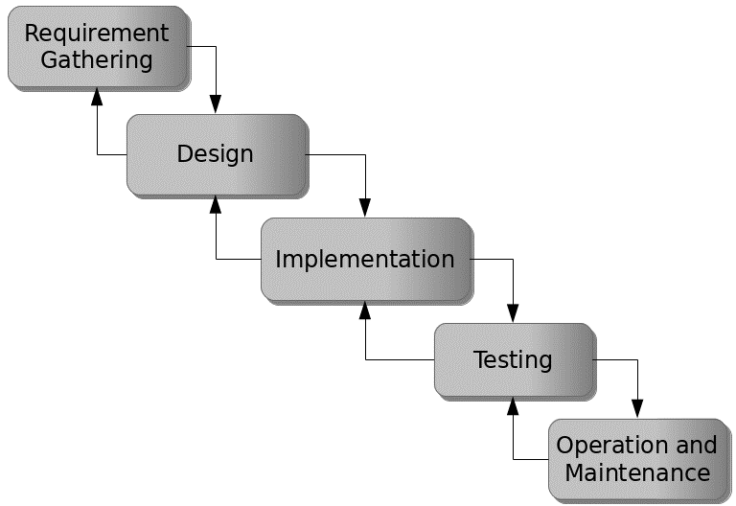

Figure 3.1: Waterfall model

## 3.5 Method of Data Collection

This study will adopt two methods of data collection which are the primary and secondary method.

## 3.6 System Design

Systems design is the process of defining the architecture, modules, interfaces, and data for a system to satisfy specified requirements. Systems design could be seen as the application of systems theory to product development.

## 3.6.1 Algorithm Diagram

**Use Case Diagram**

A use case diagram at its simplest is a representation of a user’s interaction with the system and depicting the specifications of a use case.

Login

Add Victim

Add Offender

View/Edit/Delete

Admin

Report Abuse

Approve/Decline Report

Print Report

Log out

User

Figure 3.2: Use case diagram

## 3.6.2 System Architecture

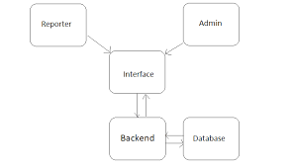

Figure 3.3: System Architecture

## 3.6.3 Database Tables/Queries Structures

## Table 3.1: Offenders Table

|  |  |  |  |  |
| --- | --- | --- | --- | --- |
| **Field** | **Datatype (length)** | **Null** | **Key** | **Extra** |
| id | int(10) | NO | PRIMARY | auto_increment |
| fullname | varchar(50) | YES |  |  |
| Photograph | varchar(50) | YES |  |  |
| Status | Int(10) | YES | FOREIGN |  |
| Email | varchar(50) |  |  |  |
| Nature of Abuse | int(10) |  |  |  |
| Date | timestamp |  |  |  |

#### Table 3.2: Child’s Table

|  |  |  |  |  |  |
| --- | --- | --- | --- | --- | --- |
| **Field** | **Type** | **Null** | **Key** | **Default** | **Extra** |
| id | int(10) | NO | PRI |  | auto_increment |
| childname | varchar(50) | YES |  |  |  |
| age | varchar(50) | YES |  |  |  |
| gender | varchar(50) | YES |  |  |  |
| Parentname | varchar(50) | YES |  |  |  |
| Status | varchar(50) | YES |  |  |  |
| Date | current_timestamp() |  |  |  |  |

#### Table 3.3: Admin Login Table

|  |  |  |  |
| --- | --- | --- | --- |
| **Field** | **Type** | **Key** | **Extra** |
| id | int(10) | PRI | auto_increment |
| First name | varchar(50) |  |  |
| lastname | varchar(50) |  |  |
| Username | varchar(50) |  |  |
| Password | varchar(50) |  |  |
| Photograph | varchar(50) |  |  |
| Date | timestamp |  |  |

**3.6.4 Database Entity Relationship Diagram**

This shows the relationship of the various tables in the database with each other

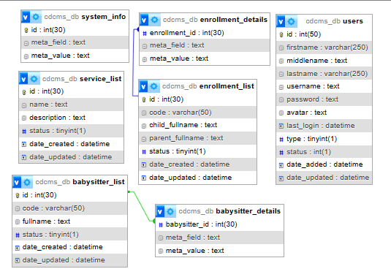

Figure 3.4: Database Entity Relationship Diagram

## 3.6.5 Input and Output Design

**LOGIN**

Enter Username

Enter Password

**Login**

Figure 3.5: Login interface

First name

Gender:

First Name

Contact Nol

**REPORT ENROLLMENT FORM**

Last Name:

Last Name

PARENTS/GUARDIAN DETAILS

Address

Othername:

Date of Birth:

Middle Name

Email

**CANCEL**

**SUBMIT**

Figure 3.6: Sign Up Form

First Name

Last Name

**child offender form**

Nature of Abuse

Photograph

Middle Name

Gender

Date

Address

SUBMIT

CANCEL

Figure 3.7: Child Offender Interface

| **#** | **Date** | **Child (Victim) Name** | **Parents/Guardian** | **Status** |
| --- | --- | --- | --- | --- |
| 1 | August 18, 2023 | HAFSAT AHMED | INUSA SARAYA | Confirmed |
| 2 | July 28, 2023 | ALIYU MUBARAK | UMAR SANI | Confirmed |
| 3 | July 18, 2023 | HAFSAT AHMED | HABIBU AHMED | Pending |

Figure 3.8: Report Interface

| **#** | **Date** | **Child Offender** | **Nature of Abuse** | **Status** |
| --- | --- | --- | --- | --- |
| 1 | August 18, 2023 | HAFSAT AHMED | INUSA SARAYA | Active |
| 2 | July 28, 2023 | ALIYU MUBARAK | UMAR SANI | Active |
| 3 | July 18, 2023 | HAFSAT AHMED | HABIBU AHMED | Pending |

Figure 3.9: Child Offenders Report Interface

**Name**

**User name**

**NEW USER**

**Password**

**User Type**

**SAVE**

**CANCEL**

Figure 3.10: Add User Interface

## 3.7 System Requirements Specification

## 3.7.1 Hardware Requirements

The software designed needed the following hardware for an effective operation of the newly designed system.

1. A system running on intel, P(R) duo core with higher processor
2. The-Random Access Memory (RAM) should be at least 512mb.
3. Enhanced keyboard.
4. At least 20-GB hard disk.
5. V.G.A or a colored monitor.

## 3.7.2 Software Requirements

The software requirements include:

1. A window 7 or higher version of operating system.
2. XAMP or WAMP for Database
3. PHP

## 3.7.3 Personnel Requirements

Any computer literate who has a technical knowhow of internet surfing can use the system because it is user friendly.

# CHAPTER FOUR

# RESULTS AND DISCUSSION

## 4.1 Introduction

The new system is designed using PHP and MySQL programming language for easy records inserting and updating. This system will help in managing and easily retrieving of information from the system for management purposes.

## 4.2 Results

## 4.2.1 Welcome Interface

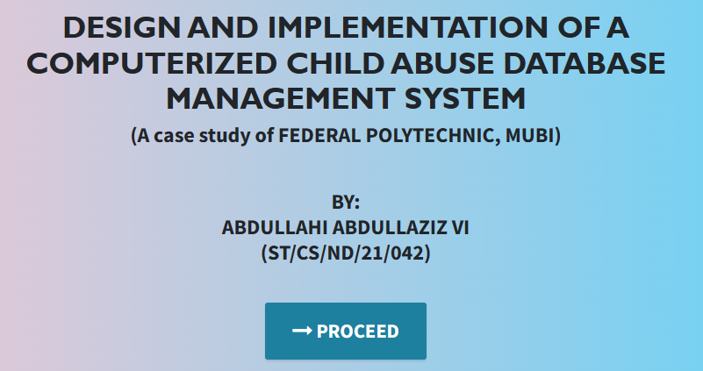

Figure 4.1: Welcome Interface

The above figure 4.1 shows the welcome page of the system, the welcome page is the first page that displays on opening the program.

## 4.2.2 Login Interface

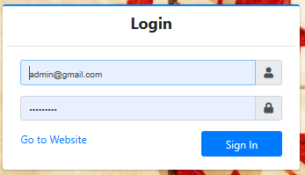

Figure 4.2: Login page interface

Figure 4.2 above shows the system login page interface. The login interface allows the users and Administrator to enter his username and password to get access to the system.

## 4.2.3 Report Abuse Interface

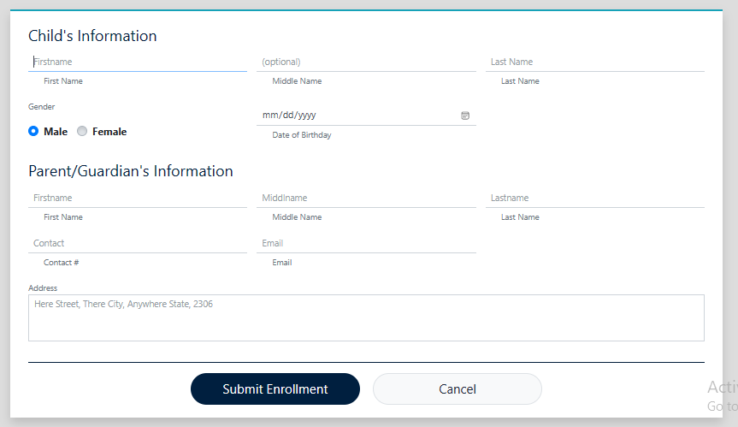

Figure 4.3: Report Abuse Interface

Figure 4.3 above shows where users can report child abuse incidence in the system

## 4.2.4 Offenders List interface

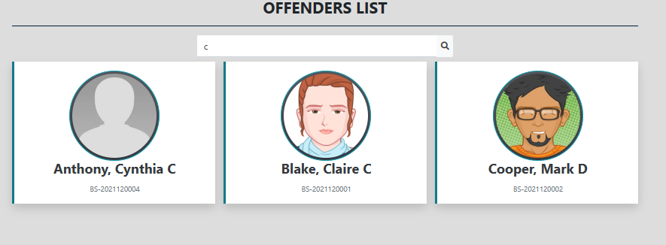

Figure 4.4: Offenders List Interface

Figure 4.4 interface shows the offenders of child abuse incidence that have been reported and confirmed in the system.

## 4.2.5 Dashboard Interface

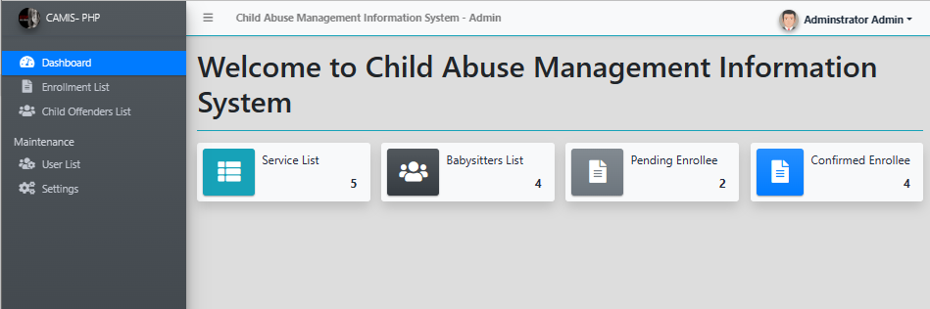

Figure 4.5: Dashboard Interface

Figure 4.5 above displays the admin dashboard showing all the tasks that can be performed in the system.

## 4.2.6 Reported Cases Interface

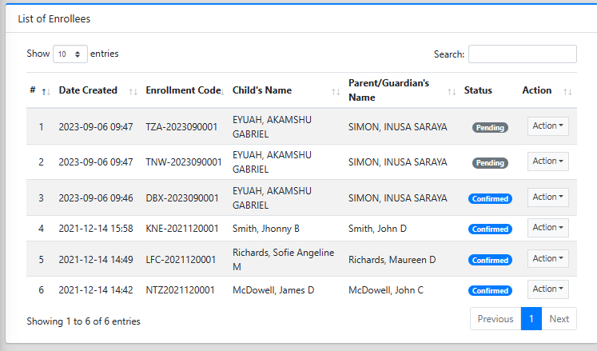

Figure 4.6: Reported Cases Interface

## 4.3 Discussion

The "Welcome Interface" (Figure 4.1) serves as the first point of interaction for users accessing the Child Abuse Database Management System. It is a critical component as it creates the initial impression and sets the tone for the system. The Welcome Interface typically includes a welcoming message, possibly the organization's logo or branding, and instructions on how to proceed. Its purpose is to make users feel comfortable, provide guidance, and encourage them to navigate further into the system.

The "Login Page Interface" (Figure 4.2) is where authorized users enter their credentials to access the system. This interface plays a vital role in ensuring data security and privacy. It typically includes fields for usernames and passwords, and in some cases, may incorporate additional security measures such as multi-factor authentication. Proper design and security in this interface are crucial to prevent unauthorized access and protect sensitive child abuse case data.

The "Report Abuse Interface" (Figure 4.3) is a crucial element of the system, allowing individuals or authorities to report cases of child abuse. It should be user-friendly, encouraging individuals to provide accurate and comprehensive information about abuse incidents. This interface may include fields for incident details, victim information, location, and the option to attach evidence or documents. Ensuring ease of use in this interface is essential to encourage timely reporting and intervention.

The "Offenders List Interface" (Figure 4.4) is where information related to individuals involved in child abuse cases, such as perpetrators or alleged offenders, is recorded and managed. This interface assists law enforcement and child protection agencies in tracking and managing offender data. It may include details like names, aliases, photographs, and case history, helping professionals make informed decisions about investigations and interventions.

The "Dashboard Interface" (Figure 4.5) serves as a central hub for data visualization and analysis. It provides an overview of key performance indicators, trends, and statistics related to child abuse cases. A well-designed dashboard offers professionals and decision-makers quick access to critical information, enabling them to monitor the effectiveness of interventions, allocate resources, and make informed policy decisions.

The "Reported Cases Interface" (Figure 4.6) displays a comprehensive list of reported child abuse cases within the system. Users can search, filter, and sort through reported cases for further analysis and action. This interface is vital for case management, ensuring that reported incidents are appropriately processed, investigated, and documented.

In summary, each of these interface figures plays a specific role in the "Design and Implementation of Computerized Child Abuse Database Management System." Together, they contribute to the system's effectiveness in managing and addressing child abuse cases, from reporting to intervention and analysis. Proper design and usability of these interfaces are critical to the success of the system and its mission of protecting vulnerable children.

## 4.4 User manual

The following are the necessary steps to take in order to use the system efficiently and effectively.

1. Load the url of the system <https://localhost/childabuse/> the welcome page will be displayed.
2. Click on the **Proceed** button to proceed to the main system.
3. If you created an account, provide your login details by entering your username and password.
4. Depending on the login details provided you will be automatically directed to the dashboard.
5. The various task that you can perform on the portal will be displayed on the sidebar of the dashboard.

# CHAPTER FIVE

# SUMMARY, CONCLUSION AND RECOMMENDATIONS

## 5.1 Summary

The "Design and Implementation of Computerized Child Abuse Database Management System" represents a crucial step forward in addressing the pressing issue of child abuse. This study introduces a comprehensive system, CADMS (Computerized Child Abuse Database Management System), designed to streamline the collection, storage, and retrieval of crucial data related to child abuse cases. CADMS offers user-friendly interfaces for case registration, victim and perpetrator profiling, evidence management, and reporting, facilitating real-time data sharing among relevant stakeholders. This summary provides an overview of CADMS's objectives, design, and potential impact on child protection efforts.

## 5.2 Conclusion

In conclusion, the design and implementation of CADMS mark a significant milestone in the ongoing battle against child abuse. This system offers a robust and accessible platform for child protection agencies, law enforcement, and social workers to manage and analyze critical data related to child abuse cases. CADMS not only centralizes information but also enhances collaboration among stakeholders, leading to more effective interventions and resource allocation. By harnessing technology, CADMS empowers professionals to make informed decisions and monitor trends, ultimately advancing the cause of child protection.

## 5.3 Recommendations

Based on findings, I recommend the following:

1. Child protection agencies and law enforcement should consider adopting CADMS or similar systems to improve their response to child abuse cases.
2. Ongoing training and support should be provided to users to ensure the effective utilization of CADMS.
3. Continuous monitoring and evaluation of the system's performance are essential for maintaining data accuracy and system integrity.
4. Stakeholders should explore opportunities for CADMS integration with existing child welfare and law enforcement databases to enhance information sharing and interoperability.

## 5.4 Contribution to Knowledge

This study contributes to knowledge by introducing CADMS as a practical solution to enhance child abuse data management. It highlights the significance of user-friendly interfaces and real-time data sharing in the context of child protection. Furthermore, it underscores the transformative potential of technology in addressing critical societal issues such as child abuse.

## 5.5 Area for Further Work

There are several avenues for further research in this domain:

Evaluating the long-term impact of CADMS on child abuse prevention and intervention outcomes.

Investigating the scalability of CADMS for use in different regions and by organizations of varying sizes.

Exploring advanced data analytics and machine learning techniques to improve the identification and prevention of child abuse cases.

Assessing the ethical and legal considerations surrounding the use of CADMS, including data privacy and security.

# REFERENCES

Adams, K. (2022). The Role of Automation in Educational Financial Management. *Journal of Information Technology in Education,* 15(3), 120-135.

Aguinis, K., & Kraiger, J. (2022). The Impact of Payment Systems on Error Reduction in Educational Institutions. *International Journal of Educational Finance,* 20(1), 56-70.

Allen, D. & James, M. (2021). Retaining Talent: The Relationship between Rewards, Engagement, and Turnover. *Journal of Management,* 46(8), 1300-1328.

Allen, D. G., Bryant, P. C., & Vardaman, J. M. (2021). Retaining Talent: The Relationship between Rewards, Engagement, and Turnover. *Journal of Management,* 46(8), 1300-1328.

Anderson, L., & Schalk, S. (2018). Ensuring Data Security in Payment Systems for Educational Institutions. *International Journal of Cybersecurity*, 18(1), 45-60.

Armstrong, M. (2019). *Armstrong's Handbook of Human Resource Management Practice*. Kogan Page Publishers.

Bendl, Y. (2021). Application of Predictive Modeling in Education: A Review. *Journal of Computers in Education,* 8(1), 19-37.

Cable, S. M., & Judge, A. (2016). Success Factors and Barriers of Adopting the Automated System of Student Affairs in Saudi Universities. *International Journal of Higher Education,* 8(3), 1-9.

Denisi, U. & Kluger, W. (2020). Mobile Property Management Systems: A Study of Design and Implementation. *Information Systems Frontiers*, 1-14.

Elmasri, R., & Navathe, S. B. (2019). *Fundamentals of Database Systems.* Pearson, New York.

Ghazal, O., Ionita, H. & Gorges, O. (2020). An Artificial Intelligence Platform for Property Management: *A Conceptual Model. Computers in Industry*, 125, 103-379.

Goblar, N. (2022). Decision Support System in Higher Education: A Case Study of an Adaptive Learning Management System. *Journal of Computers in Education,* 8(2), 215-239.

Illmakunnas, H. (2023). Adoption of E-payment Systems in Higher Education: A Comparative Study*. International Journal of Educational Technology*, 14(3), 57-72.

Jagero, R., & Kangethe, A. (2020). The Importance of Financial Transparency in Educational Institutions. *Journal of Education Finance and Policy,* 25(2), 89-104.

Jurban, L., Turner, R., & Gonzalez, E. (2023). Improving Financial Management in Universities with Payment Systems. *Journal of Higher Education Management,* 16(2), 78-92.

Kalesh, S. & Tuwei, J. (2022). Web-based Rental Property Management System for Efficient and Effective Property Management. *Journal of Engineering Technology*, 18(1), 221-229.

Kapoor, A., & Singh, P. (2020). Digital Transformation in Compensation and Benefits Management. *International Journal of Recent Technology and Engineering*, 9(2), 6742-6746.

Lazear, S., & Rosen, M. (2023). Student Perspectives on Payment Systems in Higher Education. *International Journal of Educational Technology*, 15(1), 34-48.

Liu, K., Letchkov, N., Koychev, I., & Ivanov, B. (2020). Cloud-Based Property Management Systems. *In Proceedings of the International Conference on Advances in Business, Management and Law*, 7(1), 169-177.

Mahmud, N. (2020). Evaluation of Records Management Systems in Public Universities in Kenya. *International Journal of Information Systems and Project Management,* 8(3), 43-62.

Martins, A., Proença, T., & Gonçalves, R. (2020). Employee Compensation, Incentives, and Innovation. *Research in Human Resource Management (RHRM),* 12(1), 45-54.

Mathe, U., Lee, L., Ming, I., & Hashim, L. (2021). The Role of Management Information Systems in Data Analytics: A Strategic Perspective on Global Business Environments. *Information Systems Frontiers,* 22(4), 909-924.

Motahari-Nezhad, H. R., Stephenson, B., Shahbazian, M., & Foster, H. (2021). Database Management Systems. *In Handbook on Securing Cyber-Physical Critical Infrastructure* (pp. 195-217). Springer.

Olivera, M. & Martins, L. (2021). The Adoption of Property Management Systems in the Real Estate Sector. *Journal of Business and Management*, 23(2), 71-92.

Poon, J. M. (2019). The Impact of Non-Financial Rewards on Employee Engagement and Retention. *Employee Relations*, 41(2), 333-348.

Rahman, L., Huang, O., Tim, R. & Gehrke, J. (2020). *Database Management Systems*. McGraw-Hill.

Ramakrishnan, M. & Gehrke, M. (2020). An Integrated Framework for E-Records Management System (ERMS) Development: A Study on Bangladesh Government Sector. *International Journal of Electronic Government Research*, 16(3), 19-38.

Reddy, B. S., & Kumar, G. P. (2021). Personalized Compensation and Benefits: A New Paradigm. *International Journal of Applied Engineering Research*, 16(1), 69-73.

Rizvi, S., Khan, M. A., Bhatti, R. A., & Ziauddin, Z. (2021). A Comparative Study of Database Management Systems. *Journal of Information Systems and Technology Management*, 18, 202-1134.

Shore, F. (2019). A Model for Developing a Student Management System (SMS) in Saudi Universities. *Journal of Educational Computing Research,* 58(3), 523-552.

Singhal, J. (2021). Digital Transformation in Higher Education: Advancements and Challenges. *International Journal of Educational Technology,* 12(4), 65-79.

Tziner, J. & Vardi, K. (2018). Cloud-Based Property Management System with Mobile Integration for Small and Medium-Sized Landlords. *Journal of Systems and Information Technology*, 23(3), 486-503.

Vroom Q. (2017). A Framework for Smart Rental Property Management. *IEEE Access*, 8, 134127-134139.

Wasana, A. (2020). Design and Development of Mobile Applications for Property Management. *International Journal of Information Systems and Project Management,* 9(2), 5-19.

Wayne, K. (2022). Digitalizing Student Fee Management: Challenges and Opportunities. *Journal of Educational Administration,* 46(1), 89-105.

Welch, M., & Jackson, S. E. (2017). Rethinking Diversity in Research on Organizations: Toward a Structural Perspective. *Research in Organizational Behavior*, 27, 3-30.

Wu, L., & Zhu, C. (2021). Security Considerations in Designing University Payment Systems. *Journal of Information Security,* 35(2), 213-228.

# APPENDIX A

## Welcome Interface



## Login Interface



## Report Abuse Interface



## Offenders List interface



## Dashboard Interface



## Reported Cases Interface



# APPENDIX B

**PROGRAM CODE**

    < <!DOCTYPE html>

<html lang="en" class="" style="height: auto;">

<head>

  <style>

    :root{

      --base_url:http://localhost/childAbuse/cdcms/;

    }

  </style>

    <meta charset="utf-8">

    <meta name="viewport" content="width=device-width, initial-scale=1">

    <title>Child Abuse Management Information System</title>

    <link rel="icon" href="http://localhost/childAbuse/cdcms/uploads/logo-1693990617.png" />

    <!-- Google Font: Source Sans Pro -->

    <!-- <link rel="stylesheet"

  </head>  <body class="sidebar-mini layout-fixed control-sidebar-slide-open layout-navbar-fixed sidebar-mini-md sidebar-mini-xs" data-new-gr-c-s-check-loaded="14.991.0" data-gr-ext-installed="" style="height: auto;">

    <div class="wrapper">

     <style>

  .user-img{

        position: absolute;

        height: 27px;

        width: 27px;

        object-fit: cover;

        left: -7%;

        top: -12%;

  }

  .btn-rounded{

        border-radius: 50px;

  }

</style>

<!-- Navbar -->

      <nav class="main-header navbar navbar-expand navbar-light border  border-info border-top-0  border-left-0 border-right-0 navbar-light text-sm shadow-sm">

        <!-- Left navbar links -->

        <ul class="navbar-nav">

          <li class="nav-item">

          <a class="nav-link" data-widget="pushmenu" href="#" role="button"><i class="fas fa-bars"></i></a>

          </li>

          <li class="nav-item d-none d-sm-inline-block">

            <a href="http://localhost/childAbuse/cdcms/" class="nav-link"><b>Child Abuse Management Information System - Admin</b></a>

          </li>

        </ul>

        <!-- Right navbar links -->

        <ul class="navbar-nav ml-auto">

          <!-- Navbar Search -->

          <!-- <li class="nav-item">

            <a class="nav-link" data-widget="navbar-search" href="#" role="button">

            <i class="fas fa-search"></i>

            </a>

            <div class="navbar-search-block">

              <form class="form-inline">

                <div class="input-group input-group-sm">

                  <input class="form-control form-control-navbar" type="search" placeholder="Search" aria-label="Search">

                  <div class="input-group-append">

                    <button class="btn btn-navbar" type="submit">

                    <i class="fas fa-search"></i>

                    </button>

                    <button class="btn btn-navbar" type="button" data-widget="navbar-search">

                    <i class="fas fa-times"></i>

                    </button>

                  </div>

                </div>

              </form>

            </div>

          </li> -->

          <!-- Messages Dropdown Menu -->

          <li class="nav-item">

            <div class="btn-group nav-link">

                  <button type="button" class="btn btn-rounded badge badge-light dropdown-toggle dropdown-icon" data-toggle="dropdown">

                    <span><img src="http://localhost/childAbuse/cdcms/uploads/avatar-1.png?v=1639468007" class="img-circle elevation-2 user-img" alt="User Image"></span>

                    <span class="ml-3">Adminstrator Admin</span>

                    <span class="sr-only">Toggle Dropdown</span>

                  </button>

                  <div class="dropdown-menu" role="menu">

                    <a class="dropdown-item" href="http://localhost/childAbuse/cdcms/admin/?page=user"><span class="fa fa-user"></span> My Account</a>

                    <div class="dropdown-divider"></div>

                    <a class="dropdown-item" href="http://localhost/childAbuse/cdcms//classes/Login.php?f=logout"><span class="fas fa-sign-out-alt"></span> Logout</a>

                  </div>

              </div>

          </li>

          <li class="nav-item">

          </li>

         <!--  <li class="nav-item">

            <a class="nav-link" data-widget="control-sidebar" data-slide="true" href="#" role="button">

            <i class="fas fa-th-large"></i>

            </a>

          </li> -->

        </ul>

      </nav>

      <!-- /.navbar -->     </style>

<!-- Main Sidebar Container -->

      <aside class="main-sidebar sidebar-dark-primary elevation-4 sidebar-no-expand bg-gradient-dark">

        <!-- Brand Logo -->

        <a href="http://localhost/childAbuse/cdcms/admin" class="brand-link bg-transparent text-sm shadow-sm">

        <img src="http://localhost/childAbuse/cdcms/uploads/logo-1693990617.png" alt="Store Logo" class="brand-image img-circle elevation-3 bg-black" style="width: 1.8rem;height: 1.8rem;max-height: unset;object-fit:scale-down;object-position:center center">

        <span class="brand-text font-weight-light">CAMIS- PHP</span>

        </a>

        <!-- Sidebar -->

        <div class="sidebar os-host os-theme-light os-host-overflow os-host-overflow-y os-host-resize-disabled os-host-transition os-host-scrollbar-horizontal-hidden">

          <div class="os-resize-observer-host observed">

            <div class="os-resize-observer" style="left: 0px; right: auto;"></div>

          </div>

          <div class="os-size-auto-observer observed" style="height: calc(100% + 1px); float: left;">

            <div class="os-resize-observer"></div>

          </div>

          <div class="os-content-glue" style="margin: 0px -8px; width: 249px; height: 646px;"></div>

          <div class="os-padding">

            <div class="os-viewport os-viewport-native-scrollbars-invisible" style="overflow-y: scroll;">

              <div class="os-content" style="padding: 0px 8px; height: 100%; width: 100%;">

                <!-- Sidebar user panel (optional) -->

                <div class="clearfix"></div>

                <!-- Sidebar Menu -->

                <nav class="mt-4">

                   <ul class="nav nav-pills nav-sidebar flex-column text-sm nav-compact nav-flat nav-child-indent nav-collapse-hide-child" data-widget="treeview" role="menu" data-accordion="false">

                    <li class="nav-item dropdown">

                      <a href="./" class="nav-link nav-home">

                        <i class="nav-icon fas fa-tachometer-alt"></i>

                        <p>

                          Dashboard

                        </p>

                      </a>

                    </li>

                    <li class="nav-item">

                      <a href="http://localhost/childAbuse/cdcms/admin/?page=enrollment" class="nav-link nav-enrollment">

                        <i class="nav-icon fas fa-file-alt"></i>

                        <p>

                          Enrollment List

                        </p>

                      </a>

                    </li>

                    <li class="nav-item">

                      <a href="http://localhost/childAbuse/cdcms/admin/?page=babysitters" class="nav-link nav-babysitters">

                        <i class="nav-icon fas fa-users"></i>

                        <p>

                          Child Offenders List

                        </p>

                      </a>

                    </li>

                                        <li class="nav-header">Maintenance</li>

                    <li class="nav-item dropdown">

                      <a href="http://localhost/childAbuse/cdcms/admin/?page=user/list" class="nav-link nav-user_list">

                        <i class="nav-icon fas fa-users-cog"></i>

                        <p>

                          User List

                        </p>

                      </a>

                    </li>

                    <li class="nav-item dropdown">

                      <a href="http://localhost/childAbuse/cdcms/admin/?page=system_info" class="nav-link nav-system_info">

                        <i class="nav-icon fas fa-cogs"></i>

                        <p>

                          Settings

                        </p>

                      </a>

                    </li>

                  </ul>

                </nav>

                <!-- /.sidebar-menu -->

              </div>

            </div>

          </div>

          <div class="os-scrollbar os-scrollbar-horizontal os-scrollbar-unusable os-scrollbar-auto-hidden">

            <div class="os-scrollbar-track">

              <div class="os-scrollbar-handle" style="width: 100%; transform: translate(0px, 0px);"></div>

            </div>

          </div>

          <div class="os-scrollbar os-scrollbar-vertical os-scrollbar-auto-hidden">

            <div class="os-scrollbar-track">

              <div class="os-scrollbar-handle" style="height: 55.017%; transform: translate(0px, 0px);"></div>

            </div>

          </div>

          <div class="os-scrollbar-corner"></div>

        </div>

        <!-- /.sidebar -->

</html>

<h1>Welcome to <?php echo $_settings->info('name') ?></h1>

<hr class="bg-light">

<?php if($_settings->userdata('type') != 3): ?>

<div class="row">

          <div class="col-12 col-sm-6 col-md-3">

            <div class="info-box">

              <span class="info-box-icon bg-light elevation-1"><i class="fas fa-file-alt"></i></span>

              <div class="info-box-content">

                <span class="info-box-text">Pending Applications</span>

                <span class="info-box-number text-right">

                  <?php

                    $pending = $conn->query("SELECT * FROM `leave_applications` where date_format(date_start,'%Y') = '".date('Y')."' and date_format(date_end,'%Y') = '".date('Y')."' and status = 0 ")->num_rows;

                    echo number_format($pend            </div>

            <!-- /.info-box -->

          </div>

          <!-- /.col -->

          <div class="col-12 col-sm-6 col-md-3">

            <div class="info-box mb-3">

              <span class="info-box-icon bg-info elevation-1"><i class="fas fa-building"></i></span>

              <div class="info-box-content">

                <span class="info-box-text"> Departments</span>

                <span class="info-box-number text-right">

                  <?php

                    $department = $conn->query("SELECT id FROM `department_list` ")->num_rows;

                    echo number_format($department);

                  ?>

                </span>

              </div>

              <!-- /.info-box-content -->

            </div>

            <!-- /.info-box -->

          </div>

          <!-- /.col -->

          <!-- fix for small devices only -->

          <div class="clearfix hidden-md-up"></div>

          <div class="col-12 col-sm-6 col-md-3">

            <div class="info-box mb-3">

              <span class="info-box-icon bg-lightblue elevation-1"><i class="fas fa-th-list"></i></span>

              <div class="info-box-content">

                <span class="info-box-text"> Designations</span>

                <span class="info-box-number text-right">

                <?php

                    $designation = $conn->query("SELECT id FROM `designation_list`")->num_rows;

                    echo number_format($designation);

                  ?>

                </span>

              </div>

              <!-- /.info-box-content -->

            </div>

            <!-- /.info-box -->

          </div>

          <div class="col-12 col-sm-6 col-md-3">

            <div class="info-box mb-3">

              <span class="info-box-icon bg-purple elevation-1"><i class="fas fa-list"></i></span>

              <div class="info-box-content">

                <span class="info-box-text">Promotion Types</span>

                <span class="info-box-number text-right">

                <?php

                    $leave_types = $conn->query("SELECT id FROM `leave_types` where status = 1 ")->num_rows;

                    echo number_format($leave_types);

                  ?>

                </span>

              </div>

              <!-- /.info-box-content -->

            </div>

            <!-- /.info-box -->

          </div>

        </div>

<?php else: ?>

  <div class="row">

    <div class="col-12 col-sm-6 col-md-3">

      <div class="info-box">

        <span class="info-box-icon bg-light elevation-1"><i class="fas fa-file-alt"></i></span>

        <div class="info-box-content">

          <span class="info-box-text">Pending Applications</span>

          <span class="info-box-number text-right">

            <?php

              $pending = $conn->query("SELECT * FROM `leave_applications` where date_format(date_start,'%Y') = '".date('Y')."' and date_format(date_end,'%Y') = '".date('Y')."' and status = 0 and user_id = '{$_settings->userdata('id')}' ")->num_rows;

              echo number_format($pending);

            ?>

            <?php ?>

          </span>

        </div>

        <!-- /.info-box-content -->

      </div>

      <!-- /.info-box -->

    </div>

    <div class="col-12 col-sm-6 col-md-3">

      <div class="info-box">

        <span class="info-box-icon bg-lightblue elevation-1"><i class="fas fa-th-list"></i></span>

        <div class="info-box-content">

          <span class="info-box-text">Promotion Requests</span>

          <span class="info-box-number text-right">

            <?php

              $upcoming = $conn->query("SELECT * FROM `leave_applications` where date(date_start) > '".date('Y-m-d')."' and status = 1 and user_id = '{$_settings->userdata('id')}' ")->num_rows;

              echo number_format($upcoming);

            ?>

            <?php ?>

          </span>

        </div>

        <!-- /.info-box-content -->

      </div>

      <!-- /.info-box -->

    </div>

  </div>

<?php endif; ?>